**SUMMARY RESULTS**

1. **What is the correlation (R2 value) between sales and income?**

The Correlation between sales and income is 0.78

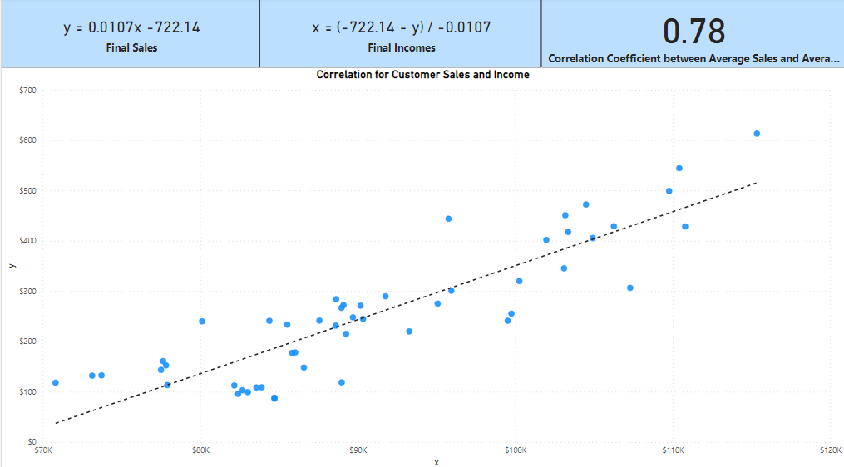

1. **What is the correlation (R2 value) between customer ratings and product return rate?**

The Correlation between sales and income is 0.78

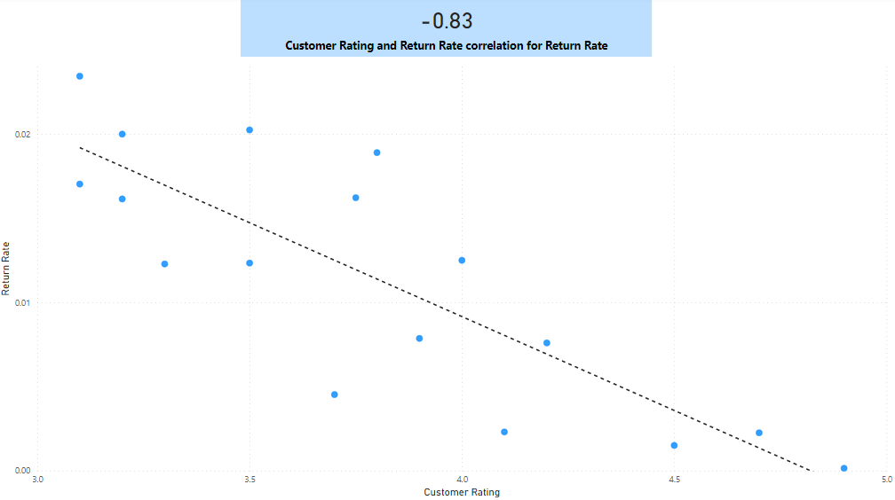

1. **What are the linear regression formulas to predict customer income from customer sales?**

The linear regression formulas:

* Predict customer sales **y = 0.0107x - 722.14**
* Predict customer incomes **x = (-722.14 – y) / -0.0107**

1. **Which customer do you predict has the highest income?**

The customer is **Jon Little** his predicted income is **$558,143,93**.

1. **Which product will be advertised the most?**

The most advertised product is the sweater and It is recommended to 660 customers representing 66% of the total.

